Platform independent language means once compiled you can execute the program on any platform (OS).

Java is platform independent. Because the Java compiler converts the source code to bytecode, which is Intermidiate Language. Bytecode can be executed on any platform (OS) using JVM( Java Virtual Machine).

Process of java code for machine :

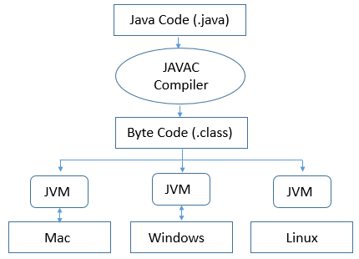

Java is platform independent hence it also called WORA that means “**Write Once, Run Anywhere**” .